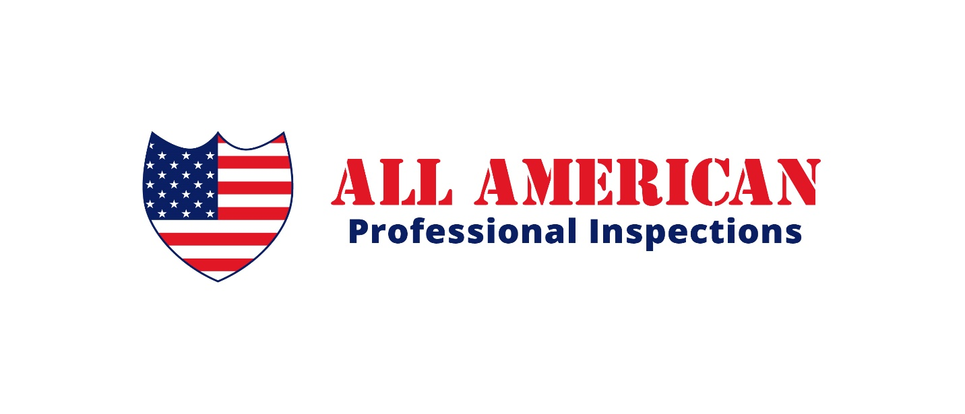

informative news about home inspections and pest control for buyers and agents!

Newsletter #2017-02

This is the November 2017 Newsletter

The Benefits of a Pre-Listing Inspection

Most real estate agents that I know never inform their Sellers on the benefits of getting a pre-listing inspection before listing the house for sale. As a matter of fact, in the 13 years that I’ve been doing inspections in the south Texas area, I’ve only known a handful of agents that inform their Sellers of such a thing.

There’s several benefits in getting a house inspected before selling it. For starters, you remove the element of surprise. In other words, now you won’t get surprised when a potential buyer gets the house inspected and tells your A/C system is too small for the house, or that your house has an active termite infestation that you didn’t even know about.

Also, a Seller gets the chance to start repairing things that would otherwise turn off a potential Buyer. For example, if the tiled floor in the living area has settling cracks that could lead a skeptic buyer into thinking the house might have foundation problems, when indeed it doesn’t, the Seller can be proactive and replace these tiles with some new tiles or carpet.

Another thing that comes to mind, is if the house has an active termite infestation, the Seller might want to get this professionally treated, and then pass on the termite warranty over to the Buyer. This way the potential buyer does not get turned off or have the chance to use it as a negotiating tool against the Seller to go down on the price!

If you are getting ready to put your house on the market, we recommend you call us to discuss the possibility of getting a pre-listing inspection.

