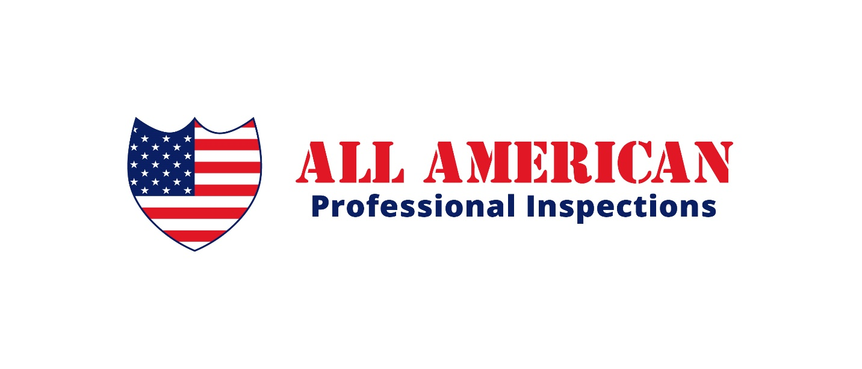

informative news about home inspections and pest control for buyers and agents!

Newsletter #2018-01

How to inspect and prevent rodent infestations.

On average, half of the houses that I inspect have a rodent infestation of some degree. Some homes have a small problem with very little evidence of infestation such as tunnels and trails in the insulation, or material chewing. Others houses have much more evidence of infestation such as droppings and urine stains. Most of the time, rodents will hide and will not be seen during an inspection; but a general rule of thumb is that if rodent droppings are present, it is likely the house has an active infestation.

I always recommend that a qualified and licensed pest contractor do an eradication treatment. I never recommend the sellers to do their own treatments personally. It is more likely that a complete eradication will take place when a professional does the work, than when a non-professional does it.

Sometimes when our Pest Control company gets called to do residential rodent control, all we have to do is seal the entry points around the exterior of the house and most of the time that completely takes care of the problem. We don’t even have to use rodenticides or mechanical traps.

As a TREC inspector (licensed by the Texas Real Estate Commission), we are not required by the state to inspect for pests such as rodents. However, since we also do professional pest management, we are trained to inspect for all types of pests, including rodents.

A pest inspection is part of my general home inspection. Not only do I look for evidence of a rodent problem, but I also look for their possible entry points all around the house.

